PROJECT DESIGN PHASE-1 PROBLEM SOLUTION FIT

|  |  |
| --- | --- |
| Team ID | PNT2022TMID52818 |
| Project Name | Car Resale Value Prediction |
| Maximum Marks | 2 Marks |

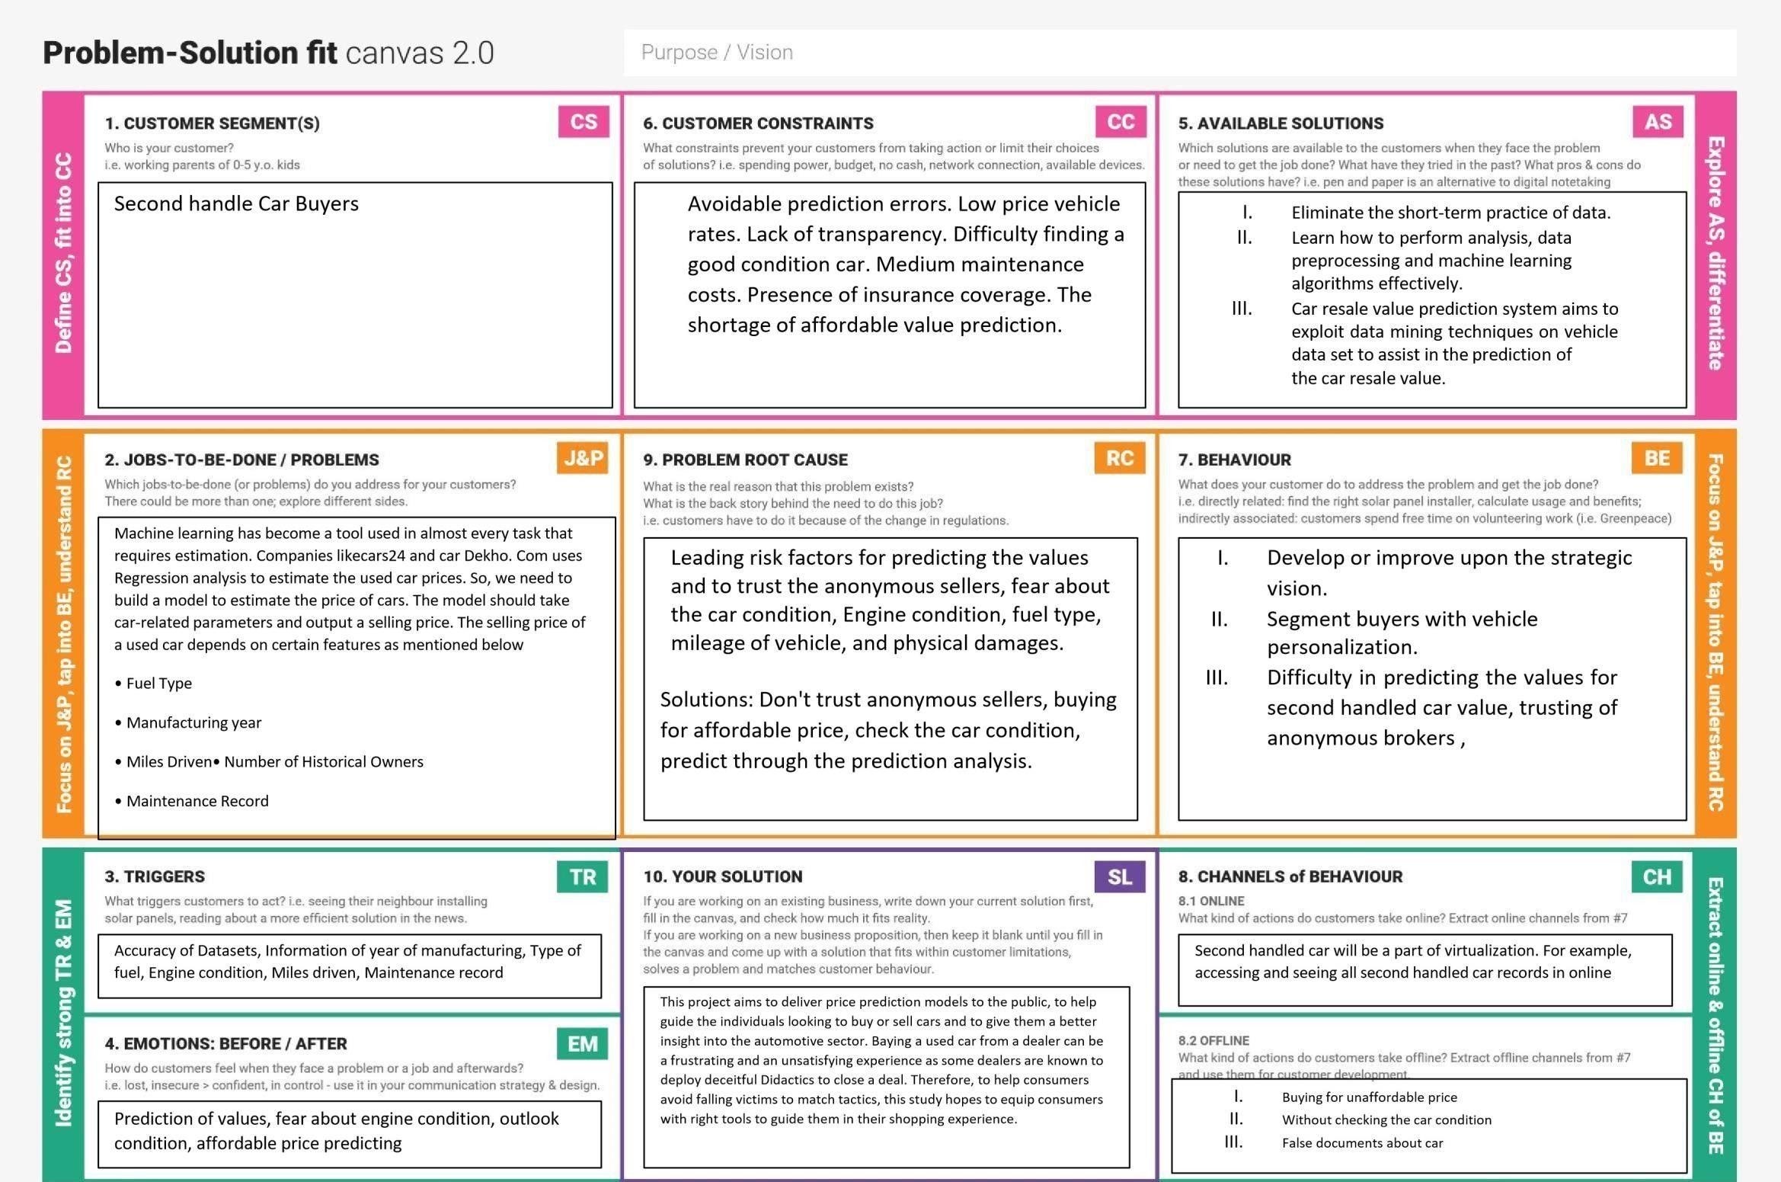

**Project Title : Car Resale Value Prediction Project Design Phase I : Solution Fit Template Team ID: PNT2022TMID52818**